Catch the Sun and Warm Your Home!

Materials: A4 or letter-sized (8.5 x 11 inches) paper, scissors, tape, sheet plastic, ruler, 2 identical thermometers.

Step 1: Fold one sheet paper in half. Repeat lengthwise so that you have a sheet of paper divided into four rectangles.

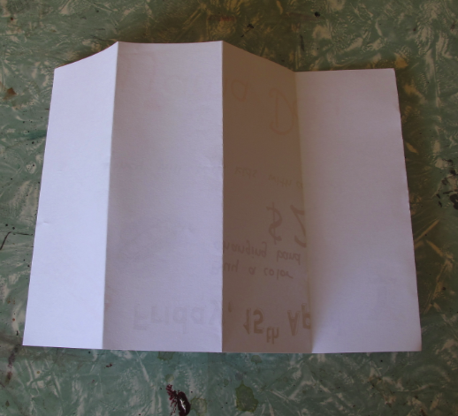

Step 2: Cut one quarter strip off, and then cut that in half. Save the two small pieces for us in step 5.

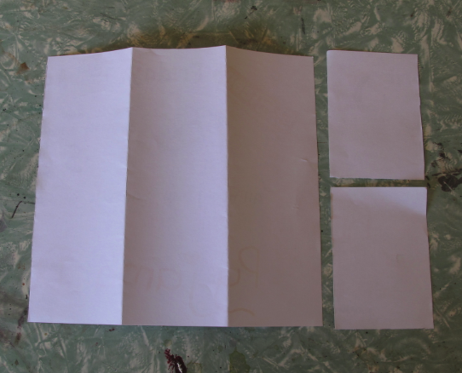

Step 3: In the middle section, draw a rectangle centred 1 cm from the bottom and top and 2 cm from the sides. Cut out the rectangle.

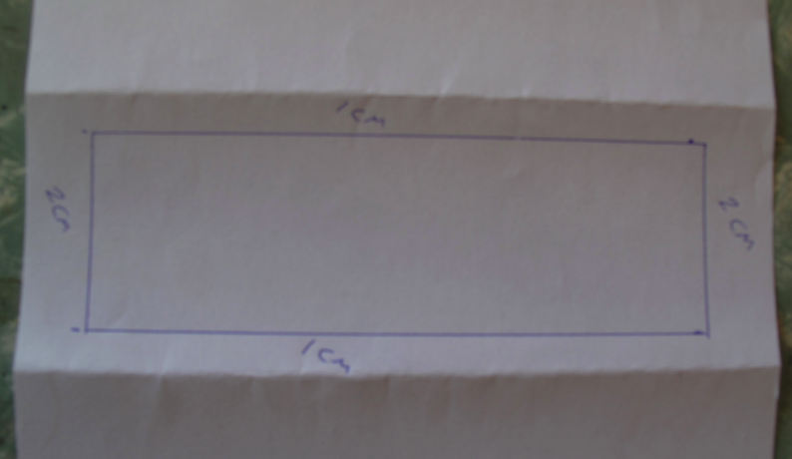

Step 4: Cut a piece of clear plastic (saran wrap will do) that is just bigger than the hole you cut in the paper. Tape the plastic on the inside of the rectangle. Use long strips of tape to seal up all gaps to prevent air flow.

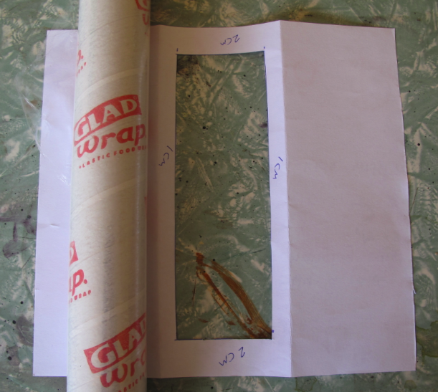

Step 5: Place one of the small pieces of paper from step 2 on the table. Set the triangular house frame on top of it and carefully mark the 3 corners. Make sure you match the top of the triangle with the top of the small piece of paper. Repeat for the other end.

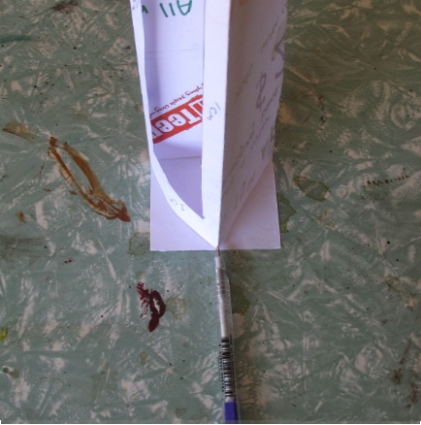

Step 6: Use a ruler to draw a triangle connecting the 3 marks you made in step 5. Carefully fold exactly on the lines. This makes a triangle with 3 flaps. The flaps help to reduce air flowing through the model. Tape the flaps down on both sides.

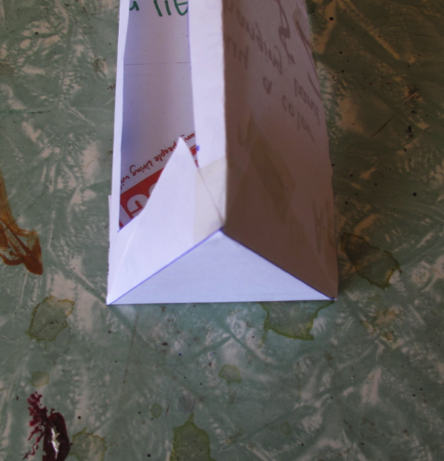
Step 7: You should now have a sealed model for a passive solar home. Put a small hole in the back corner so you can insert a thermometer. This can be an electronic one or a standard one.

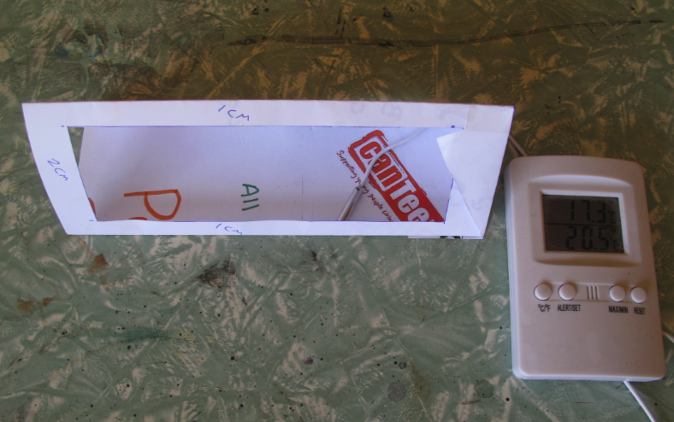

Step 8: Make another model exactly the same. Then tape a strip of paper so that it hangs down over your plastic window. This ensures a fair test.

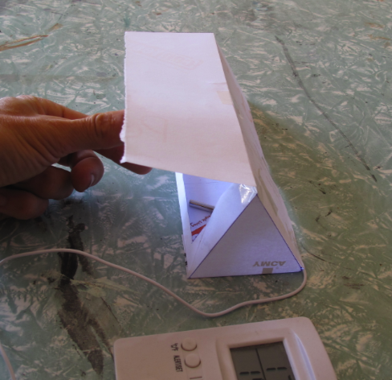

Step 9: Set the two models next to one another in a sunny spot outside on top of a piece of cardboard (in case the pavement is hot and would radiate up through the bottom of the paper models). Have two students stand so as to shade the models until the test begins. Take the temperatures in the shade. They should be the same. This is time zero.

Step 10: Have the students shading the models step away and take the temperature every minute for 10 minutes. Make a data table as shown in the Little House That Could Science Unit. Make line graphs of the data. Compare the 2 graphs.

